PILLAI COLLEGE OF ENGINEERING
(Autonomous)

Course: Digital Image Processing

Experiment No: 6
To convert a trained machine learning model into a web application interface using FastAPI and package the application environment using Docker for standardized containerized deployment.

Name: Tejas.P.Kamble  Roll No: 25  Division: A  Batch: A-2 | DOP: / /2026  DOS: / /2026  Score:  Sign:

1. Aim
To convert a trained machine learning model into a web application interface using FastAPI and package the application environment using Docker for standardized containerized deployment.

2. Objectives
- Build an interactive RESTful API endpoint (/predict) in Python using FastAPI to serve ML model predictions.
- Validate API execution and response schemas using sample JSON input payloads via Swagger UI.
- Configure a Dockerfile defining system runtime requirements, dependencies, and container entry points.
- Deploy and verify the containerized application on a local environment using Uvicorn and Docker tools.

3. Theory & Concepts
REST API & FastAPI Architecture
Machine learning models stored as raw binary files (.pkl) cannot be consumed directly by client applications. They must be exposed via Application Programming Interfaces (APIs). FastAPI is a high-performance Python framework that utilizes Pydantic for strict data validation, preventing bad inputs from crashing the underlying model.

Containerization & Docker Concepts
Deploying applications across different systems often causes dependency mismatches. Docker resolves this by packaging the application, dependencies, and environment into an isolated, reproducible container defined by a Dockerfile script.

4. Implementation Steps & Workflow
Step 1: Model Export & Environment Setup

- Trained a RandomForestClassifier on academic performance data (math, physics, chemistry) in Google Colab and serialized it to model.pkl.
- Exported the core application code (main.py), dependency list (requirements.txt), and container configuration (Dockerfile) to the local project workspace.

Step 2: Local Environment Preparation
- Installed Docker Desktop on the Windows 10 host machine to manage container execution.
- Configured local Python dependencies (fastapi, uvicorn, scikit-learn, joblib, pydantic) via pip.

Step 3: Service Deployment & Execution
- Initiated the ASGI server via Uvicorn to serve the model locally on port 8000:
uvicorn main:app --reload --port 8000
- Verified Docker configuration settings and built the container image target (edtech-api) using the project Dockerfile:
docker build -t edtech-api . docker run -p 8000:8000 edtech-api

Step 4: End-to-End Validation
- Accessed the interactive OpenAPI documentation at [http://127.0.0.1:8000/docs](http://127.0.0.1:8000/docs).
- Submitted test JSON payloads to the /predict endpoint to verify real-time status prediction outputs (Pass/Fail).

5. Implementation Code
API Source Code (main.py)

from fastapi import FastAPI
from pydantic import BaseModel
import joblib
import numpy as np

app = FastAPI(title="EdTech Student Pass Prediction API")

# Load trained Random Forest Model
model = joblib.load("model.pkl")

class StudentData(BaseModel):
math: float
physics: float
chemistry: float

@app.get("/")
def read_root():
return {"message": "EdTech Student Pass Prediction API is running!"}

@app.post("/predict")
def predict_status(data: StudentData):
features = np.array([[data.math, data.physics, data.chemistry]])
prediction = model.predict(features)[0]
return {
"input": data.dict(),
"prediction": str(prediction)
}

Containerization Script (Dockerfile)
FROM python:3.10-slim
WORKDIR /app
COPY requirements.txt .
RUN pip install --no-cache-dir -r requirements.txt
COPY main.py .
COPY model.pkl .
EXPOSE 8000

CMD ["uvicorn", "main:app", "--host", "0.0.0.0", "--port", "8000"]

Project Dependencies (requirements.txt)
fastapi
uvicorn
scikit-learn
joblib
pydantic
pandas
numpy

6. Experimental Verification & Evidence
Screenshot 1: Local Server Execution Logs
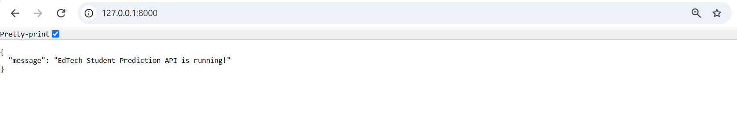Screenshot 2: Container Environment & Project Deliverables
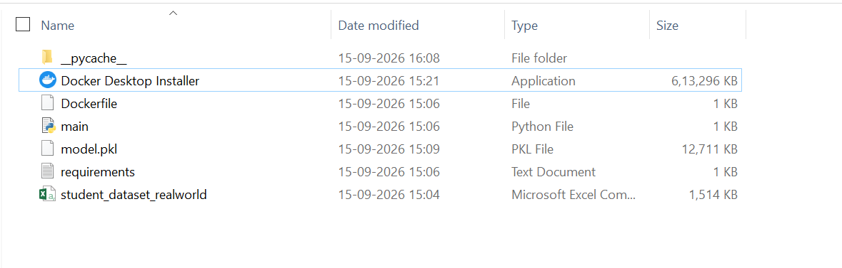
Project Workspace & Docker Deliverables Directory Structure

Screenshot 3: Interactive Swagger UI Prediction Evidence
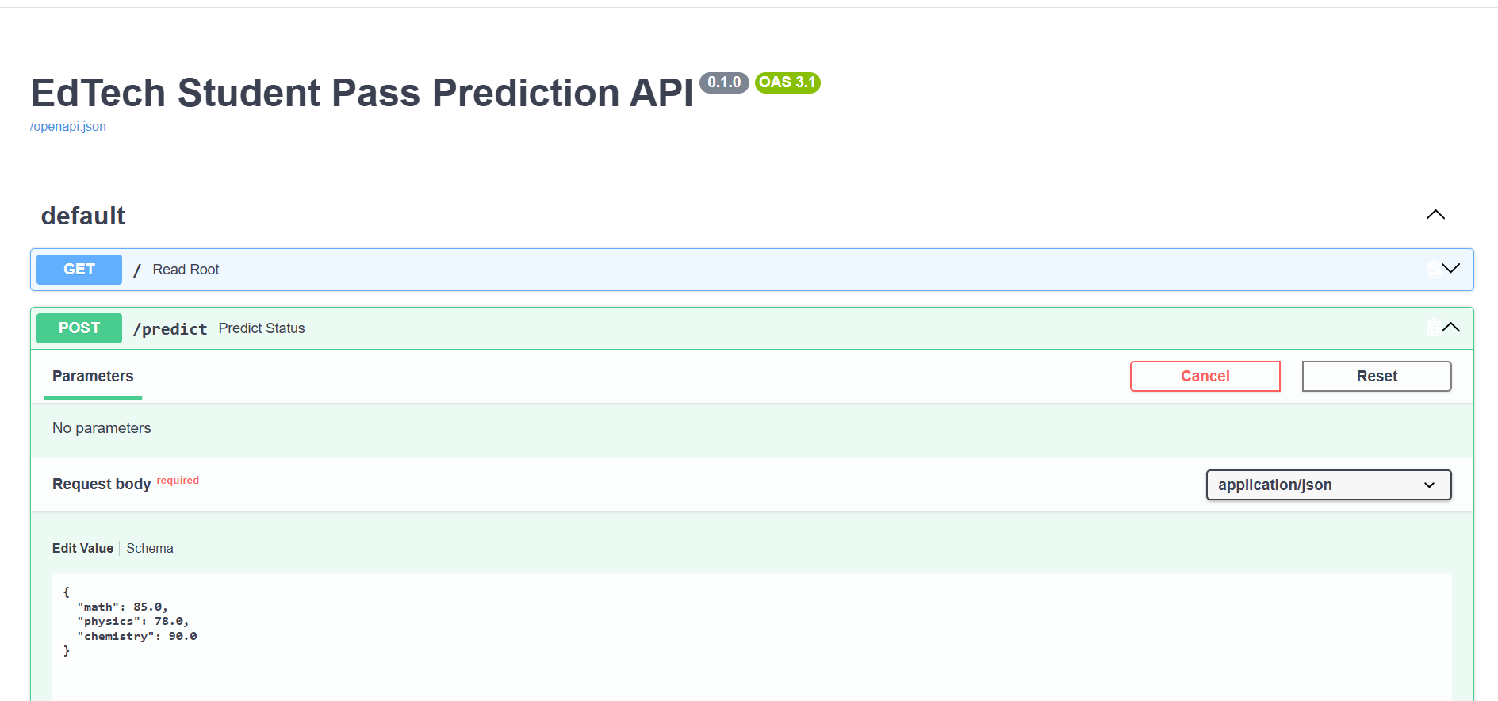

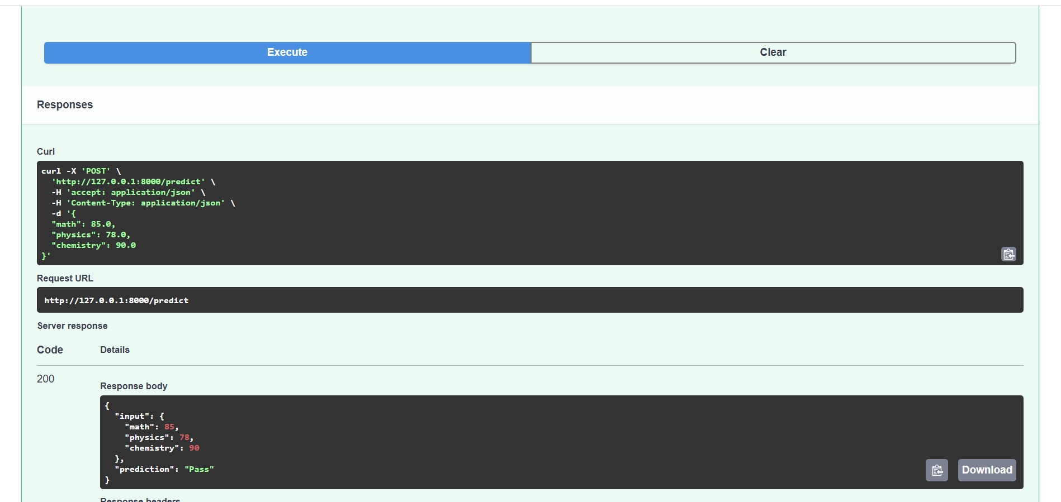

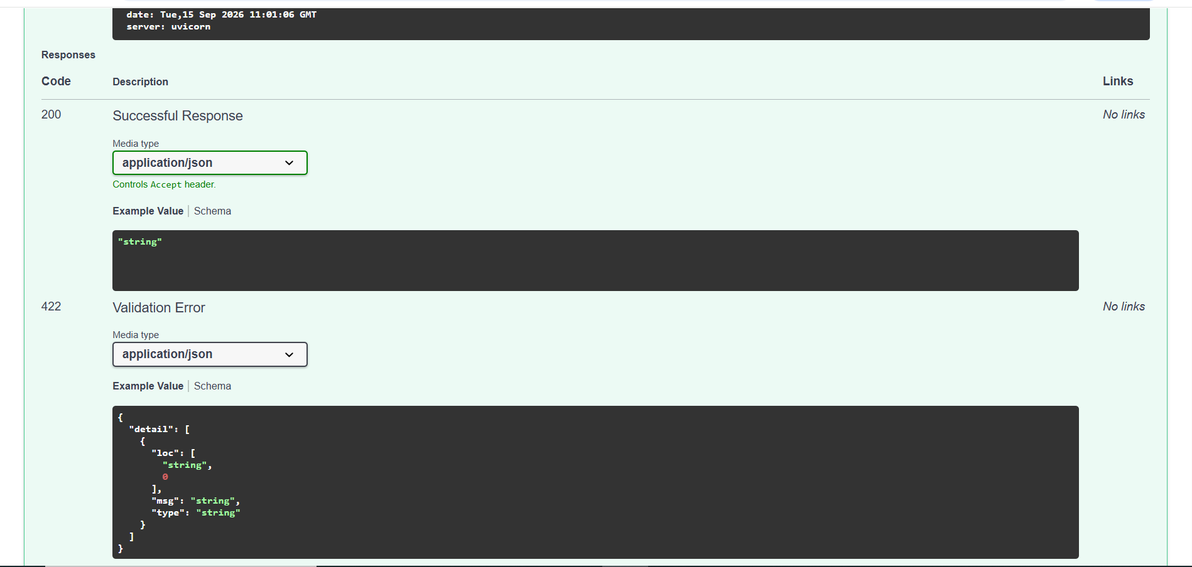

7. Conclusion
In this experiment, an end-to-end machine learning deployment pipeline was successfully implemented. The trained student performance model (model.pkl) was served as a RESTful web service using FastAPI, enabling real-time inference via JSON payload requests. The container environment was defined using a Dockerfile, Docker tools were configured, and the service was verified via Uvicorn on port 8000 with a successful HTTP 200 OK response. .

